Name
Institution
Course
Instructor
Date

Apple Inc. Persona
Apple is one of the largest companies in the world and the largest company when it comes to technological products. The company has developed its products to become the most valuable brand around the world. the company generated up to $274.5 in 2020. Apple Inc. mainly deals with designing and manufacturing electronic products such as personal computers, smartphones, tablets, wearables as well as a number of services to its customers. There are numerous Apple stores around the world with the headquarters situated in California. The company in its mission statements states that its main aim is to bring the best experience to its customers including engineers, students, and scientists through innovative computing products. The company’s vision is to make products that are the best while making the world a better place.
Personas
Nate Roberts works as a 37-year-old civil engineering assistant in San Diego. He earns up to $76000 per year with a disposable income of $30000 a year. Christine Williams is a 46-year-old professor who lives in New York earns up to $65000 a year. She has a disposable income of $25000 in the year. Richard Lawson aged 45 owns a textile company in Los Angeles. He earns up to $80,000 per year and has a disposable income of $34000 in a year (Indeed, 2021)
Full Built Persona
Nate Roberts aged 37 years old has been a civil engineering assistant for over 7 years. He has worked on various projects within the organization as well as on behalf of the organization. He works and lives in San Diego but often goes on various field projects as part of his assignments.
One of the challenges that Nate has been facing is the lack of a reliable smartphone to support his communication and project needs while working on field projects. He has been having issues with receiving and storing large files on his phone which limits his ability to work efficiently when not close to his computer in the office. Sometimes Nate is also afraid of storing important information on his phone due to the possibility of data breaches from his android phone (Benenson, et al. 2019). He is frustrated that in many cases he has to wait until he goes back to his office to be able to view data sent to him which greatly delays his responses.
Reliable products
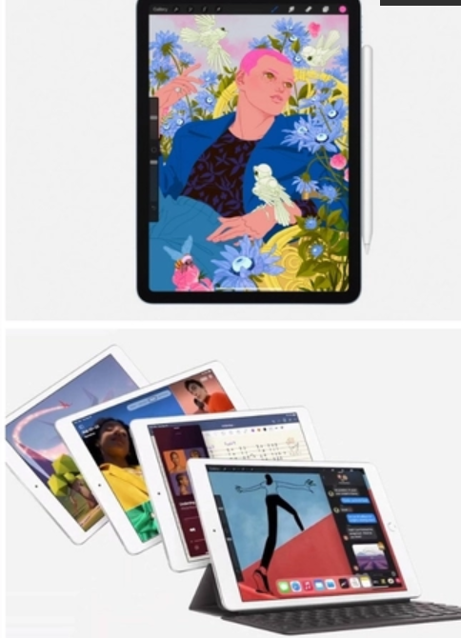
Nate requires a new brand that will give him a reliable experience including portability as well as reliable storage for important work files. He is also looking for a brand that ensures a high level of data security and privacy without subjecting him to any possible breaches which may lead to him losing his data. The new iPhone and iPads from Apple can be some of the reliable products that Nate can opt for based on his desired experience. Apple products always ensure a high level of privacy and protection and protect the users from data breaches frequently associated with android products (Benenson, et al. 2019).
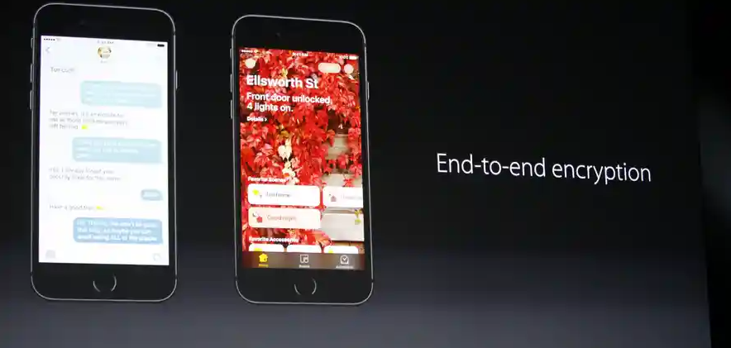
Nate owns a Sedan which he usually uses to move around when working on field projects. In his car, he usually likes to listen to the radio to keep him informed. He is also a great sports fan who spends a considerable time on his weekends watching various sporting activities including football and soccer with friends and family. He has a desktop computer in his office and an android smartphone which he uses to communicate as well as receive work updates. He would like to have a more reliable gadget with high memory, good display as well as proper protection from data breaches to make his work easier when not close to his computer.
Work cited
Benenson, Z., Gassmann, F., & Reinfelder, L. (2019). Android and iOS users' differences concerning security and privacy. In CHI'13 Extended Abstracts on Human Factors in Computing Systems (pp. 817-822).
Indeed, (2021), engineering jobs. [online] Indeed.com. Available at: <https://www.indeed.com/q-Engineering-l-California-jobs.html?vjk=baa91b80da51a37c> [Accessed 19 October 2021].

